Department of Computer Science and Engineering
Assignment Questions
Course Code & Name : ITA0605 – Machine Learning
Assignment Title: | Intelligent Healthcare Diagnosis and Patient Risk Prediction System Using Machine Learning
Course Outcome(s) – CO: | CO1: Acquire a foundational understanding of key machine learning concepts including version spaces, candidate elimination, inductive bias, and heuristic search.  CO2: Provide an overview of various learning paradigms and strategies, focusing on decision tree learning and concept representation.  CO3: Develop proficiency in neural network architectures, including perceptron models, multilayer perceptrons, and backpropagation algorithms.  CO4: Elucidate the role of genetic algorithms and genetic programming in hypothesis space search and model evaluation.  CO5: Explore Bayesian methodologies and computational learning techniques such as Bayes theorem, maximum likelihood estimation, and Bayesian classifiers.
Bloom’s Taxonomy Level | L3 – Apply; L4 – Analyse; L5 – Evaluate; L6 – Create
SDG Mapping (SDG 1-17) | SDG 3 – Good Health and Well-Being  SDG 9 – Industry, Innovation and Infrastructure  SDG 10 – Reduced Inequalities
Problem Statement: Design, implement, and evaluate an Intelligent Healthcare Diagnosis and Patient Risk Prediction System using machine learning techniques.
A healthcare organization wants to develop a machine learning-based prototype that can assist healthcare professionals in analysing patient information and predicting potential health-risk categories. The system will use a suitable healthcare dataset containing attributes such as age, gender, blood pressure, blood glucose level, cholesterol level, body mass index (BMI), heart rate, medical history, and other relevant clinical parameters.
The proposed system should analyse the patient data and classify patients into appropriate risk categories, such as Low Risk, Moderate Risk, or High Risk, based on the selected healthcare problem and dataset
The final system should integrate the above techniques into a comprehensive machine learning workflow:
Healthcare Dataset → Data Preprocessing → Statistical Analysis → Feature Selection → Model Development → Prediction → Model Evaluation → Risk Classification
Students should compare the performance of the implemented approaches and identify the most suitable technique for the selected healthcare prediction problem.
The system should provide meaningful outputs such as:
• Predicted patient-risk category
• Important clinical attributes
• Model accuracy and other evaluation measures
• Comparison of different machine learning algorithms
• Visual representation of prediction results

Project Write-up

Intelligent Healthcare Diagnosis and Patient Risk Prediction System
The project aims to design and implement a machine learning-based healthcare system that analyses patient clinical information and predicts their health-risk category as Low Risk, Moderate Risk, or High Risk. The system will assist healthcare professionals by providing data-driven predictions and identifying the clinical factors that contribute most to patient risk.

1. Dataset Collection
First, select a suitable healthcare dataset containing patient-related attributes such as Age, Gender, Blood Pressure, Blood Glucose, Cholesterol, BMI, Heart Rate, medical history, and other clinical parameters. The dataset should also contain a target variable representing the disease, condition, or risk level to be predicted. Suitable datasets can be obtained from sources such as Kaggle or UCI.

2. Data Preprocessing
The collected dataset needs to be cleaned before applying machine learning algorithms. This includes:
- Handling missing and duplicate values
- Removing irrelevant attributes
- Converting categorical data such as Gender into numerical form
- Detecting and handling outliers
- Scaling numerical features where required
- Splitting the dataset into training and testing data

3. Statistical Analysis and Visualization
Perform basic statistical analysis to understand the dataset. Calculate measures such as mean, median, standard deviation, minimum and maximum values. Generate visualizations such as histograms, box plots, correlation heatmaps, and class-distribution charts to identify patterns and relationships between clinical attributes and patient risk.

4. Feature Selection
Identify the most important clinical features that influence the prediction. Techniques such as correlation analysis, SelectKBest, Recursive Feature Elimination (RFE), or feature importance can be used. This reduces unnecessary features and can improve model performance.

5. Model Development
Implement and compare multiple classification algorithms. A suitable set would be:
- Logistic Regression
- Decision Tree
- Random Forest
- K-Nearest Neighbors (KNN)
- Support Vector Machine (SVM)
The models will be trained using the selected features and training dataset.

6. Risk Prediction
After training, the models will be used to predict the risk category of unseen patient data. The system should accept patient clinical information as input and produce an output such as:
Patient Risk: High Risk
It should also display the important clinical factors influencing the prediction.

7. Model Evaluation
Evaluate each model using appropriate classification metrics such as:
- Accuracy
- Precision
- Recall
- F1-Score
- Confusion Matrix
The results of all algorithms should be compared to determine which model provides the best performance for the selected healthcare problem.

8. Final System and Visualization
Finally, integrate all stages into one workflow:
Healthcare Dataset → Preprocessing → Statistical Analysis → Feature Selection → ML Models → Prediction → Evaluation → Risk Classification
The final prototype should provide patient-risk predictions, important clinical attributes, model performance results, comparison graphs, confusion matrices, and other visualizations. The best-performing algorithm will be selected as the final model.

Expected Outcome
The completed project should demonstrate how machine learning can be used to analyse healthcare data and classify patients according to their potential health risk. It should provide a clear comparison of different ML techniques and identify the most suitable model for the chosen healthcare prediction problem.

Aim:
To design, implement, and evaluate an Intelligent Healthcare Diagnosis and Patient Risk Prediction System using machine learning techniques to analyse patient clinical data and classify patients into Low Risk, Moderate Risk, or High Risk categories.

Algorithm:
- Load the healthcare dataset.
- Preprocess and clean the data.
- Select important clinical features.
- Split data into training and testing sets.
- Train ML models: Logistic Regression, Decision Tree, Random Forest, KNN, and SVM.
- Evaluate models using Accuracy, Precision, Recall, and F1-score.
- Select the best-performing model.
- Predict the patient's Low, Moderate, or High Risk.
- Display the prediction and model performance.
- Stop.

Dataset: Heart Disease Dataset
Source: Kaggle / UCI Machine Learning Repository

Attribute | Description | Type
Age | Patient age | Numerical
Sex/Gender | Male/Female | Categorical
Chest Pain Type | Type of chest pain | Categorical
Resting BP | Resting blood pressure | Numerical
Cholesterol | Serum cholesterol | Numerical
Fasting Blood Sugar | Blood glucose indicator | Numerical
Resting ECG | ECG result | Categorical
Max Heart Rate | Maximum heart rate achieved | Numerical
Exercise Angina | Angina caused by exercise | Categorical
ST Depression | ECG ST depression | Numerical
ST Slope | Slope of ST segment | Categorical
Heart Disease | Disease present/absent | Target
Pseudocode:
BEGIN
1. Load the healthcare patient dataset.
2. Display the dataset and perform initial analysis.
3. PREPROCESS DATA
a. Check for missing values.
b. Remove duplicate records.
c. Convert categorical values into numerical values.
d. Detect and handle outliers.
e. Normalize/standardize numerical features.
4. Perform STATISTICAL ANALYSIS.
a. Calculate mean, median and standard deviation.
b. Analyze relationships between clinical attributes.
c. Visualize data using graphs and charts.
5. Perform FEATURE SELECTION.
a. Apply a feature-selection technique.
b. Select the most important clinical attributes.
c. Remove unnecessary features.
6. Separate the dataset into:
X = selected patient features
Y = risk category
7. Split the data into TRAINING and TESTING sets.
8. Train different machine learning models:
a. Logistic Regression
b. Decision Tree
c. Random Forest
d. KNN
e. SVM
9. For each model:
a. Train the model using training data.
b. Predict risk categories for test data.
c. Calculate Accuracy.
d. Calculate Precision.
e. Calculate Recall.
f. Calculate F1-score.
g. Generate Confusion Matrix.
10. Compare the performance of all models.
11. Select the model with the best evaluation performance.
12. INPUT new patient clinical information.
13. Preprocess the new patient data using the same preprocessing steps.
14. Apply the selected best model.
15. Display:
a. Predicted risk category
b. Important clinical attributes
c. Model accuracy and evaluation measures
d. Model comparison
e. Prediction visualizations
END
Output:
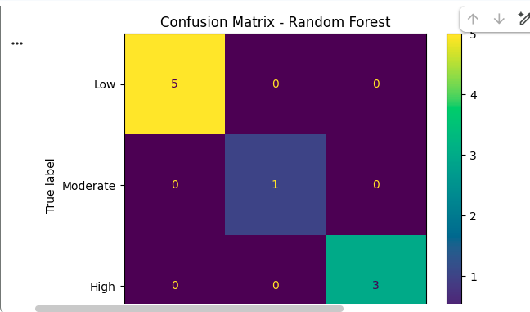
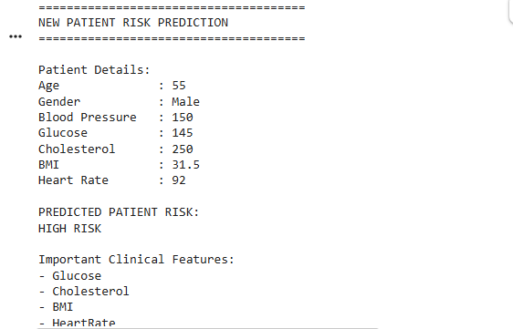

Result:
The Intelligent Healthcare Diagnosis and Patient Risk Prediction System was successfully implemented using machine learning techniques. The system preprocesses patient data, selects important clinical features, trains and compares multiple classification algorithms.

.Assessment Rubrics

Criteria (CO Mapping) | Max Marks | Excellent | Good | Satisfactory | Needs Improvement
Concept Learning: Version Space, Candidate Elimination, Inductive Bias & Heuristic Search (CO1) | 15 | Correctly formulates a healthcare concept-learning problem and clearlydemonstrates version space, candidate elimination, inductive bias, and heuristic search. | Concepts are correctly applied with minor gaps in explanation or implementation. | Basic concepts are demonstrated but with limited analysis. | Concepts are missing, incorrectly applied, or poorly explained.
Learning Paradigms & Decision Tree Learning (CO2) | 15 | Correctly implements decision tree learning, clearly represents healthcare concepts, explains attribute selection and decision rules, and interprets the results. | Decision tree is correctly implemented with minor analytical gaps. | Basic decision tree implementation is provided with limited interpretation. | Decision tree is incomplete, incorrect, or poorly interpreted.
Neural Networks: Perceptron, MLP & Backpropagation (CO3) | 15 | Successfully implements neural network architecture and backpropagation; clearly analyses training parameters and prediction performance. | Neural network is correctly implemented with minor issues. | Basic implementation works but analysis is limited. | Neural network or backpropagation implementation is incomplete or incorrect.
Genetic Algorithm / Genetic Programming (CO4) | 15 | Effectively applies genetic algorithms/programming for hypothesis search, feature selection, or model optimization and evaluates its impact. | Genetic algorithm is correctly applied with reasonable analysis. | Basic implementation is provided but optimization analysis is limited. | Genetic algorithm/programming is missing or incorrectly implemented.
Bayesian Learning & Computational Techniques (CO5) | 15 | Correctly applies Bayes theorem, MLE, and Bayesian classification with meaningful probability-based interpretation. | Bayesian techniques are correctly implemented with minor gaps. | Basic Bayesian classification is implemented with limited interpretation. | Bayesian methodology is missing or incorrectly applied.
Data Manipulation & Analysis Using NumPy and Pandas (CO7) | 15 | Efficiently performs preprocessing, statistical analysis, aggregation, feature preparation, correlation analysis, and visualization using NumPy and Pandas. | Most data-analysis tasks are correctly completed with minor issues. | Basic preprocessing and analysis are completed but lack depth. | Data manipulation and analysis are incomplete or contain significant errors.
Reflection: Design Decisions, SDG Relevance & Learning Outcomes | 10 | Thoughtful justification of design choices, clear connection to SDG 3/9/10 relevance, and honest, specific account of challenges faced and learning gained. | General justification of design choices; sustainability connection and challenges mentioned but lack depth. | Reflection present but generic; limited justification of design or vague account of learning outcomes. | No genuine reflection submitted, or content is generic with no real design/SDG/learning connection.
Deliverables
To receive full credit, each submission must include the following deliverables:
To receive full credit, each submission must include:
- Problem Definition
- Pseudocode
- Results and Discussion
- Final Report
- GitHub Upload

